REPORT FROM WARWICKSHIRE COUNTY COUNCILLOR
JAMES CROCKER

NEWS FROM SHIRE HALL
WCC approves 2026/27 budget to protect services and support residents
The budget sets out WCC’s commitment to protecting essential services, supporting council taxpayers with cost-of-living pressures and investing in key priorities against the backdrop of ongoing economic challenges.
In the Council meeting held on 17 February, Councillors approved the 2026/27 budget and the 2026-2031 medium-term financial strategy (MTFS). The medium-term financial strategy aims to maintain stable finances while ensuring Warwickshire continues to thrive.
The budget includes a 4.4% increase in Council Tax, including the 2% adult social care precept. This is lower than the maximum permitted increase of 4.99%, reflecting the Council’s wish to support residents with cost-of-living pressures. The medium-term financial strategy also sets out a programme of efficiency savings and investments to maintain WCC’s strong focus on prevention to help reduce future demand on services.
An draft budget contained proposals for new on-road parking fees in areas including Henley-in-Arden, Shipston and Alcester. At a private meeting, I personally made the case for this to be excluded, my Reform UK colleagues agreed, the proposals were removed.

Have your say on Local Government Reorganisation in Warwickshire
Government consultation on Local Government Reorganisation in Warwickshire launches and will run for seven weeks.

The government has launched a consultation to invite residents, businesses, and key stakeholders, to have their say as part of the consultation on what Local Government Reorganisation (LGR) should look like in Warwickshire.
Currently, Warwickshire has two-tiers of local government, Warwickshire County Council as one tier and five District and Borough Councils - North Warwickshire Borough, Nuneaton and Bedworth Borough, Rugby Borough, Stratford and Warwick District Councils as the second tier.
Local government reorganisation (LGR) is planned for Warwickshire because central government has set out a national policy to reorganise the current two-tier system of local government in England to one tier, and Warwickshire is one of the areas affected by that policy.
In line with the Local Authority Publicity Code, the councils are not promoting or advocating for any option within the consultation. The consultation is being led by Government, which is seeking views on the options that have been put forward.
The Government is only consulting on whether residents would prefer one unitary council for Warwickshire, or separate north and south unitary councils.
If you would like to share your views on Local Government Reorganisation in Warwickshire, the easiest way to take part is to provide your feedback through the online survey. The consultation is open from Thursday, 5 February, until Thursday, 26 March.

Potholes

The state of our roads — particularly the persistent issue of potholes — is a top priority for residents across Warwickshire. Warwickshire County Council (WCC) holds the statutory responsibility for the maintenance of our highway network, excluding motorways and major trunk roads which are managed by National Highways. The Council employs a risk-based approach to repairs, prioritising those deeper than 5cm for urgent attention, often within 24 hours, while smaller defects are scheduled for routine maintenance. We have also recently transitioned toward a "prevention over cure" strategy, utilizing dedicated "Find and Fix" teams and new AI-driven data to identify failing surfaces before they become hazardous.
Public reporting is vital to this process, as WCC cannot be held liable for damage unless they have been formally made aware of the defect. If you spot a pothole, please report it - for issues that pose an immediate, life-threatening danger, please contact the Customer Service Centre directly at 01926 412515. By providing a precise location and, if safe to do so, a photograph, you help our highways teams respond more efficiently to keep our community moving safely.
For online reporting click here: https://services.warwickshire.gov.uk/report-a-pothole/

Portraits of the Shire Hall: Saturday 21 March, from 2.00 pm to 3.15 pm.
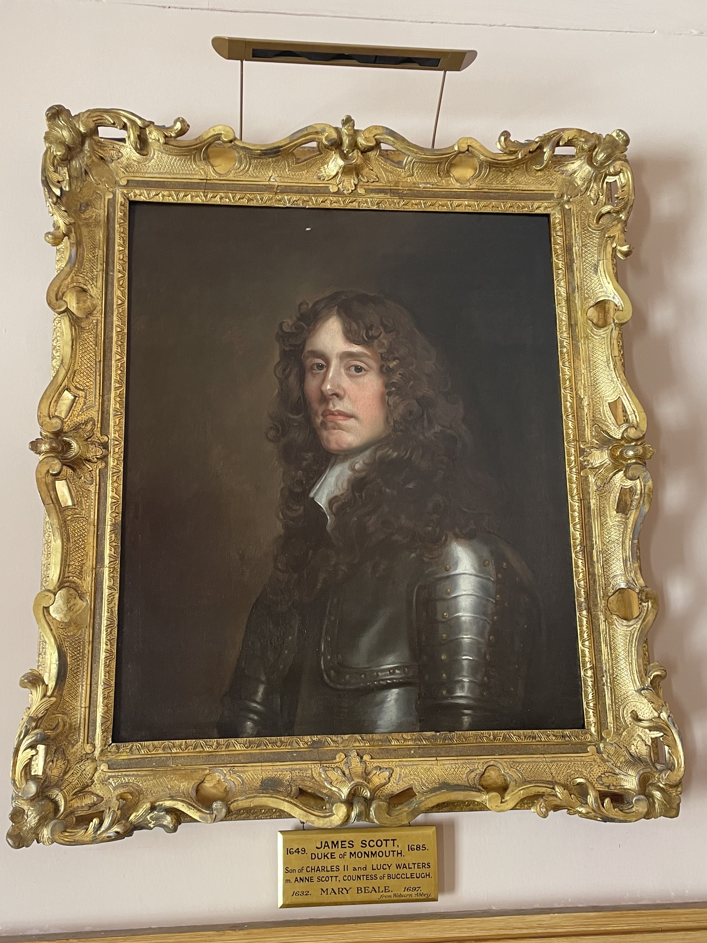
A new and exclusive walking tour at Shire Hall, Warwick, is offering art and history lovers a rare opportunity to explore one of the county’s historic portrait collections - while directly supporting a major conservation project.
Led jointly by art historian Dr Adam Busiakiewicz and historian Aaron Manning, the tour will explore the portraits and paintings housed within the Judges House. Participants will gain insight into the history of the artworks, the lives of the sitters, and the connections between monarchs, Warwick, and the surrounding region.
"Most visitors to Shire Hall probably think of the paintings collection simply as wall decoration." says Dr Busiakiewicz. He goes on to say: "However, since rediscovering Ralph Sheldon's lost portrait of the Henry VIII in the summer of 2024, hiding in plain sight in the collection there, it's been clear to me that there are more fascinating artworks waiting to be uncovered. It is a very exciting and rare opportunity to shine a light on these overlooked paintings."
Half of all ticket sales will go directly towards the restoration and future display of Ralph Sheldon’s portrait of Henry VIII.
Tickets are £20, with half of all proceeds supporting the Henry VIII Restoration Fund. Booking in advance is recommended at www.warwickshire.gov.uk/heritageboxoffice/. The tour will involve walking up steps and staircases, as well as periods of standing while viewing the paintings. Please note that the tour is not wheelchair accessible.

Talks Featuring History and Heritage this Spring at Warwickshire County Record Office
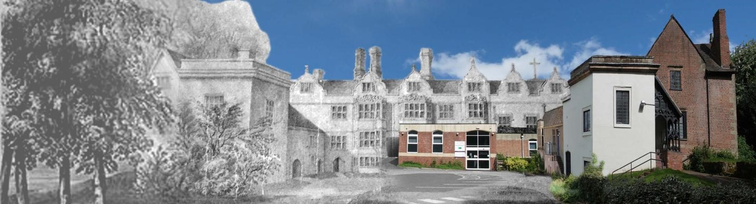
History and heritage enthusiasts can enjoy two talks at Warwickshire County Record Office this Spring.
The first talk, ‘The Puckerings and Warwick Priory’, takes place on Saturday 7th March at 2 pm.
Join historian Trevor Langley as he uncovers the tale of the Puckering family, once owners of Warwick Priory—the very site where the County Record Office stands today.
Discover how their sole heiress, Jane Puckering, was sensationally abducted from a Royal Park in London in a daring plot to seize the family fortune!
This captivating talk will also reveal stories of other wealthy and influential families who called Warwick Priory home, including the illustrious Wise family.
The second talk, Plagues, Potions & Parish Records: A Journey Through Medical History, takes place on Tuesday 24th March at 6 pm.
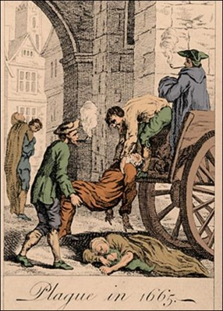
From an 18th-century recipe for “a most excellent medicine against the plague” to tales of robberies, hangings, and medical research in parish registers—the collections at the County Record Office reveal fascinating stories showing how people in the past used to prevent and treat illness.
Both events involve a short tour behind the scenes into the Strongrooms and the chance to explore documents from our collections.
The venue is wheelchair accessible.
Tickets cost £10 for each event, including tea and coffee. Booking in advance is recommended at www.warwickshire.gov.uk/heritageboxoffice

MY RESPONSIBILTIES AS WARWICKSHIRE COUNTY COUNCILLOR
- Within Warwickshire County Council, other parishes in the Arden division include Henley-in-Arden (and Beaudesert JPC), Wootton Wawen, Claverdon, Langley, Tanworth-in-Arden (including Earlswood), Wolverton and Preston Bagot.
- Serving on both the Warwickshire Fire & Rescue Local Pension Board of the Firefighters’ Pension Scheme and the Warwickshire Pension Fund Local Pension Board.
- Member of the cross-party working group for the Bus Service Improvement Plan. I have recently received a number of requests from residents asking for service extensions to key areas such as Warwick Hospital. If you have any views or suggestions regarding local bus services, please do not hesitate to get in touch.
- Appointed to the Member Oversight Group, a cross-party body focused on WCC’s investments, trading companies and including the Warwickshire Investment Fund.
- Member of the Audit & Standards Committee, concerned with ensuring that WCC has robust systems of internal control and making sure that both councillors and officers follow high standards in the way they conduct the business of the council.

Separately, also Chair of the Reform UK branch for Stratford-on-Avon.

Getting in Touch
For any issues or ideas that would benefit Ullenhall, as your representative, I am always available to listen and support local priorities at Warwickshire County Council.

James Crocker
County Councillor for Arden
Warwickshire County Council Email: jamescrocker@warwickshire.gov.uk

Mobile: 07353 157962

